REPORT
On “Introduction to Geographic Information Systems” short continuing course
held at the NUACA within the HERITAG Erasmus+ Program

The short training course titled “Introduction to Geographic Information Systems” was held at the NUACA on June 18-22, 2018 for the representatives of the Union of Inbound Tour Operators of the Republic of Armenia engaged in the HERITAG Erasmus+ project. The training was considered as an effective by evaluation of 8 staff members attended the training because the directions of application of geoinformation technologies in the field of tourism organization and management were outlined (Figure 1). The Course Description and Agenda are attached (see Annex 1). The training was organized and implemented by Scientific-Educational Reforms Foundation (SERF). The 8 training participants were awarded by the Certificate that certifies acknowledges that the participants have attended at the short training course (24 hours) on Introduction to Geographic Information Systems implemented by SERF within the framework HERITAG Erasmus+ project (see Figure 2).
Figure 1. Participants of the training course titled “Introduction to Geographic Information Systems” that was held at the NUACA on June 18-22, 2018 for the representatives of the Union of Inbound Tour Operators of the Republic of Armenia.
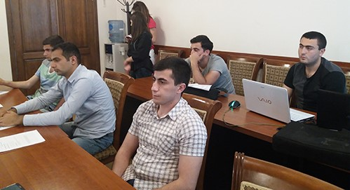

Figure 2. Certificate by which the training participants were awarded after course completion successfully.
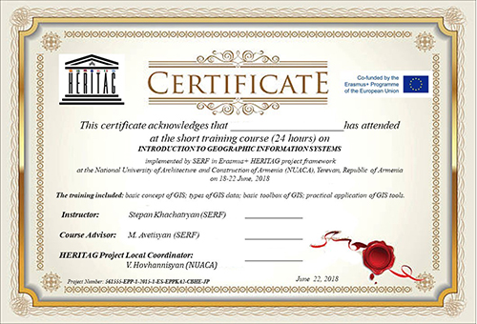

Annex 1. «Introduction to Geographic Information Systems» Course Description

This course is jointly developed by SERF, NUACA and ASUE.

AnnexGeneral Information
University |  | National University of Architecture and Construction of Armenia (NUACA),  Armenian State University of Economics (ASUE)
Course title |  | Introduction to Geographic Information Systems
Course/Module code |  | -
Course type |  | Short training course
Credits awarded (ECTS) |  | 1.5
Dates and duration (hours) |  | June 18 – 22, 2018
Entry requirements/  Competences |  | Computer skills, Basic English
Responsible person/coordinator |  | Mashtots Avetisyan, MSc (SERF)
Where |  | NUACA
Registration period |  | May 20, 2018 – June 15, 2018
Max/Min students |  | Max 20/Min 10 students
Lecturer’s details
Name, surname |  | Artak Piloyan (NUACA)
Academic title |  | Ph.D.
e-mail |  | artakpiloyan@ysu.am;
Name, surname |  | Mashtots Avetisyan (SERF)
Academic title |  | MSc
e-mail |  | mashtotsavetisyan@gmail.com
Office hours and consultation schedule |  | Every Tuesday, 15:00-16:00, NUACA, Chair of Engineering Geodesy;  Every day by e-mail,
Course Structure
Course Aim and Objectives |  | The course seeks to provide students with a basic level of familiarity with several aspects of Geographic Information Systems and Geographic Information Science, such that the range of possibilities for GIS-based work is understood and an adequate foundation for engaging those possibilities is laid.  Thus, the objectives for the course are:  - Providing an understanding of basic skills necessary to work with GIS, predominantly using ESRI’s ArcGIS software  - Introducing students to software and techniques beyond ESRI products  - Teaching spatial data visualization techniques along with introductory knowledge of effective cartography and additional software for the production of maps and other information graphics  - Teaching skills needed to develop and execute a project requiring GIS as a management, analytical, and/or visualization tool  - Identifying and accessing publicly available data sets  - Teaching the skills necessary to create GIS data through a variety of methods including those offered by global positioning system (GPS) technologies  - Providing an introductory understanding of the ethical questions surrounding data creation, analysis, and representation
Short Description |  | Geographic Information Science (GIS) is the science of linking data to locations to explore spatial relationships. GIS is way more than just maps. By evaluating the relationship between different spatial information you can identify the best location for new development, locate pollution point sources, find the easiest way to get from point A to point B, and develop a better understanding of the way the world interacts. The goals of this course are to teach you basic GIS concepts such as spatial data sources and structures, projections and coordinate systems, data editing and creation, and geospatial analysis.
Module/Topic |  | Learning Outcomes | Teaching Method | Assignments and Literature | Form of Assessment | Schedule of the Course
Lecture 1: Introduction, course overview, what is GIS  Lab 1: ArcGIS basics, loading data, scales, navigation, online help |  | K1, S1, S3 | Interactive lecture  Q&A  Practical work | Literature: Geographic Information Systems and Science; Chapter 1, 2  Getting to Know ArcGIS; Chapter 1, 2, 3, 4 | Discussion in class, Q&A | 18.06.2018  (15:00-18:00)
Lecture 2: Cartographic principles and conventions  Lab 2: Making map |  | K1, S2 | Interactive lecture  Q&A | Literature: Geographic Information Systems and Science; Chapter 3, 12  Getting to Know ArcGIS; Chapter 7, 9, 10 | Discussion in class, Q&A | 18.06.2018  (15:00-18:00)
Lecture 3: Spatial data properties and structure  Lab 3: Attribute query, joining and relating, projection |  | K2, S1 | Interactive lecture  Q&A  Practical work | Literature: Geographic Information Systems and Science; Chapter 5, 8  Getting to Know ArcGIS; Chapter 6, 15, 17 | Discussion in class, Q&A | 19.06.2018  (15:00-18:00)
Lecture 4: Spatial data management, geodatabase basics  Lab 4: Create feature classes, vector data editing, geocoding |  | K2, S1 | Interactive lecture  Q&A  Practical work | Literature: Geographic Information Systems and Science; Chapter 10  Getting to Know ArcGIS; Chapter 11, 12, 13, 14 | Discussion in class, Q&A | 19.06.2018  (15:00-18:00)
Lecture 5: Vector based spatial analysis  Lab 5: Location query, overlay and adjacency analyses |  | K2, S1 | Interactive lecture  Q&A  Practical work | Literature: Geographic Information Systems and Science; Chapter 14  Getting to Know ArcGIS; Chapter 8, 16, 18, 19 | Discussion in class, Q&A | 20.06.2018  (15:00-18:00)
Lecture 6: Raster based spatial analysis  Lab 6: Map algebra, surface analysis, raster-vector conversion, geo-referencing |  | K2, S1, | Interactive lecture  Q&A  Practical work | Literature: Geographic Information Systems and Science; Chapter 15 | Discussion in class, Q&A | 20.06.2018  (15:00-18:00)
Lecture 7: Spatial statistics and geo-statistics  Lab 7: Spatial dependency, clustering, fragmentation, interpolation |  | K2, S5 | Interactive lecture  Q&A  Practical work | Literature: Geographic Information Systems and Science; Chapter 4, 6 | Discussion in class, Q&A | 21.06.2018  (15:00-18:00)
Lecture 8: Data collection and data quality  Lab 8: Creating Smart Tourism Map of Armenia |  | K2, K3, S4, S6, A1, A3 |  | Literature: Geographic Information Systems and Science; Chapter 9 | Discussion in class, Q&A | 21.06.2018  (15:00-18:00)
Lecture 9: Network analysis  Lab 9: “Create your own most beautiful Tourism map of Armenia!” |  | K2, K3, S4, S6, A1, A3 | Interactive lecture  Q&A  Practical work | Literature: Geographic Information Systems and Science; Chapter 16 | Own analysis and map presentation | 22.06.2018  (15:00-18:00)
Teaching and Assessment Requirements |  | Teaching: The students of the course should abide the following requirements: attending the classroom for lectures, active participation in class discussions, practice work and individual work. Students are expected to attend all class sessions as listed on the course calendar. The best way to contact Instructor outside of the class hours is via email.  Assessment: Assessment will be based on student’s individual work. The individual work will test how well student can solve problems in GIS based on skills learned during the class.
Resources |  | PC for all students, ArcGIS 10.x, Internet

Learning Outcomes
Knowledge | K1 - Understand the fundamental theory of Geographic Information Science (GISc) behind Geographic Information Systems (GIS) and in so doing build an awareness of what GIS can and cannot be used for.  K2 - Become proficient in the use of GIS tools to conduct spatial analyses and build maps that are fit-for-purpose and that effectively convey the information they are intended to.  K3 - Build confidence in learning how to undertake new problems in GIS and to seek help from the GIS community (beginning with your classmates) to solve your problems.
Skills | S1 - Express an understanding of the differences between vector and raster data;  S2 - Express an understanding of coordinate systems and projections;  S3 - Produce maps that meet geographic and cartographic standards;  S4 - Analyze the spatial distribution of phenomena and provide meaningful analysis of spatial attributes;  S5 - Conduct spatial statistics on data layers  S6 – Perform Network analysis
Attitudes | A1 - Use GIS analyses to address applied problems and/or research questions.  A2 - Become efficient in building maps that can be shared with non-GIS users (e.g. PDF or JPEG maps)

